PROJECT | Flood Risk Management – Riverine Floods
LEADER / PARTNERS | Parish or Town Council, Lead Local Flood Authority (county or unitary council), Environment Agency (EA), landowners, riparian owners, DEFRA funding and policy writing. See also www.thefloodhub.co.uk
COUNCIL POWERS | Open Spaces Act 1906  Flood and Water Management Act 2010 – outlines strategies, funding and ownership aspects  EA cannot carry out work or apply levies without lead local flood authority’s permission.  Reservoir Act 1975 12A-12B – reservoir related floods  https://www.wlma.org.uk/uploads/PC_Information_for_Riparian_Owners.pdf Riparian owners advice from Water Management Alliance.  Land Drainage Act 1991
FUNDING SOURCES | To cover cost of professional assessment.  “The Environment Agency may make grants in respect of expenditure incurred or expected to be incurred in connection with flood or coastal erosion risk management in England.”  Environment Agency grants:  - To apply: you must send (a) either the FCERM 2 (Flood & Coastal Erosion Risk Management) or FCERM 7 (accessed from your local EA flood authority representative) along with (b) a completed Outline Business Case.  - Outline Business Case – if project < £3 million then single stage business case required; if project > £3 million then three stage business case required. These must follow the FCERM appraisal guidance and follow the FCERM template.
ADVICE / USEFUL CONTACTS | Environment Agency.  Grants – Flood Risk Capital Grants applications information  Water Management Alliance.  Riparian landowners rights and responsibilities
Requirements:
SKILLS | Independent flood risk assessors:  - Potential firms include Nimbus Engineering, ACCON UK, Unda Consulting, FPS Environmental, Gondolin Land & Water, Aegaea, and RSK Group.  Time and knowledge for completing Outline business case and FCERM forms.
RESOURCES | Land Registry for ownerships,  Flood Risk Capital Grants applications information  FCERM appraisal guidance  FCERM template.
MATERIALS | Depend on solutions:  - Flood gates  - Flood barriers  - Water pumps  - Airbrick  Flood Protection Solutions is a company that works with EA and sell community flood kits in small, medium and large.  Small = £3000 +VAT  Medium = £5500 +VAT  Large = £11000 +VAT  Riverbank maintenance will require contractors to have access to the riverbank with machinery.
PERMISSION | Landowners affected, planning authority, Environment Agency
CONTRACTORS | Independent flood risk assessors,  Contractors to set up the flood defences (along with volunteers if possible)
Steps to Success: | - Check if you’re living in a flood risk zone  - Commission a flood risk assessment  - Establish who is the landowner of relevant riverbanks, flood risk zones and waterways. This will need to include any houses or land that could become a new flood risk if rivers are diverted. Use HM Land Registry.  - Establish following independent risk assessment the most appropriate flood defence for each situation.  - Apply for EA permission to implement changes and EA funding for project.  - Get permission from residents affected by flood defence implementation.  - Purchase flood defences.  - Either using community volunteers or contractors set up flood defences.
Greenhouse gas reduction/  Net Zero outcomes | Unlikely – perhaps the use of gates/barriers or natural solutions can reduce use of gasoline powered generators used for pumps during floods.
Adaptation and Resilience outcomes | 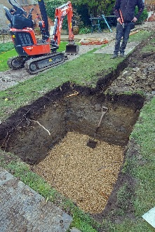  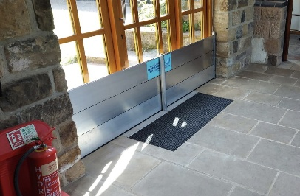  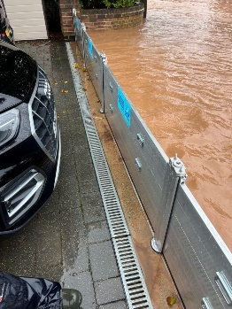  Pictures from the Flood Protection Solutions website
Biodiversity/ Nature Recovery/  Ecosystem outcomes | Saving habitats along riverbanks from being flooded.
Community/social outcomes | Maintains communities transport and accessibility to towns/shops.
Economic implications | Capital cost but saving on flood recovery/damage.
MAINTENANCE | Depending on solutions. Community flood barriers will need to be set up each time required and packed away and stored afterwards.

