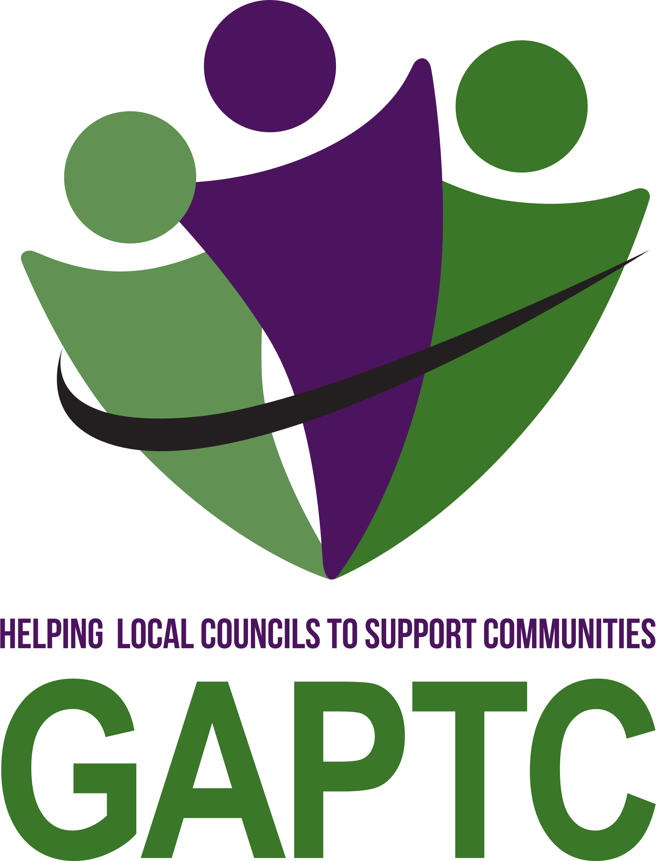

**Gloucestershire Association of Parish and Town Councils**

***You are invited to attend***

**The eighty-eighth Annual General Meeting**

on Saturday 12 July 2025

Toddington Village Hall, Stow Road, New Town, Cheltenham GL54 5DU

Registration from 9.30am

Meeting to commence at 10.00am promptly

**AGM AGENDA**

Welcome to Members by Alan Porter, Chair Executive Committee

**1. To receive apologies for absence**

**2. To approve the minutes of the eighty-seventh Annual General Meeting held on 20 July 2024 (attached)**

**3.** **To note the matters arising from the following Resolutions passed at the AGM on 20 July 2024**:

|  |  |
| --- | --- |
| **Proposition Adopted** | **Action Taken/Notes** |
| **Wotton-under-Edge Town Council**  To enable Parish and Town Councils to hold the Annual Parish Meeting at a convenient time more suitable for the electorate rather than being restricted to after 6pm when many people are unavailable. | This motion is already NALC policy. NALC seeks to extend the period for holding the Annual Parish Meeting to allow it to be held between 1 March and 30 June, and that the convenor of the meeting may fix the time before 6pm.  Note: The Local Government Act 1972 Schedule 12, Paragraph 14(1) and Paragraph 22 (3). There is no reference to the day of the week, only the time of day, and the time of year. |
| **Bourton-on-the-Water Parish Council**  That NALC should now enhance its policy to encompass the CMA’s conclusion and to lobby the new government. | GAPTC welcomes the 2024 motion as a logical extension of the 2023 policy. Substantive work has already been undertaken by NALC, including engagement with the CMA. The CMA’s findings now form part of the evidence base underpinning this policy, and the 2024 motion helps maintain momentum in lobbying the new government. No further action is required by GAPTC at this time. |
| **Bourton-on-the-Water Parish Council**  **We are seeking NALC to research to allow Parish and Town Council greater control and accountability for flooding and infrastructure. Water Companies to be held responsible for new developments to allow more control for Parish and Town Council to prevent flooding to ensure Water Companies maintain responsibility.** | GAPTC Executive Committee members considered the motion in light of knowledge that NALC was working in partnership with Kings College London to produce guidance for local councils on flood risk management. It decided to await the release of this guidance before pursuing further action. Initial guidance was released by NALC on 20 March and is available on the GAPTC website. We will continue to inform members as more guidance and information becomes available. |

**4. To adopt the 2024-2025 ANNUAL REPORT and FINANCIAL STATEMENT**

(attached)

**5. To debate the following MOTIONS**:

**Councils are reminded that the proposer must be a member of the relevant council and that a seconder from another council is present. Proposers will have four minutes to speak to their council’s motion**

**Motion 1 Parish and District Boundary Review**

Proposer: Hucclecote Parish Council

1. The National Association of Local Councils (NALC) should work with the Local Government Association, the Local Government Boundary Commission for England, the Ministry of Housing and Communities and Local Government to amend legislative procedures for neighbourhoods that straddle the boundaries of two or more district councils or unitary authorities (DCUA).

2. NALC should encourage the Government and the Local Government Association (and member councils) to pay special attention to cross border communities when establishing the boundary of newly created unitary authorities, so that they unite communities rather than entrench existing administrative divisions.

**Amendment 1.1**

Proposer: Rudford and Highleadon Parish Council

1. Any legislation should allow communities and local councils to petition concerning parish and DCUA boundaries. Proposals should be subject to appropriate consultation with neighbouringcouncils and reviewed by the LGBCE*.*

**Motion 2 Investments and the extraction and production of fossil fuels**

Proposer: Stroud Town Council

1. All member councils should be encouraged to review their investment policies and pension fund affiliations (where applicable), with the aim of divesting from companies involved in the extraction or production of fossil fuels.

2. Request that GAPTC itself investigates its own financial arrangements (e.g., banking, investments, pensions if any) and commit to divesting from fossil fuels where applicable and practicable.

3. Local Government Pension Scheme (LGPS) managers in Gloucestershire and the Brunel Pension Partnership should provide transparent reporting on fossil fuel investments and develop a credible plan for full divestment aligned with the Paris Agreement targets.

4. GAPTC should support member councils by offering or signposting resources, advice, and workshops on ethical and climate-friendly financial decision-making.

**Amendment 2.1**

Proposer: Rudford and Highleadon Parish Council

1. The Brunel Pension Partnership should take a bolder approach in its Climate Change Strategy bydivesting from, or reducing the carbon weighting of, its portfolio.

**6. To discuss the level of subscription for 2026/27, as required by Para 3b of the Constitution, for the Executive Committee to take into consideration when it sets the fee level in the autumn.**

**7. To receive any other items of urgent business as notified to the Chairman prior to the commencement of the meeting, and at the discretion of the Chairman.**

**8. Headline sponsor’s presentation**

*Parish Online*

*Parish Online provides mapping software as well as GOV.UK website, email, and cloud storage services for town, parish and community councils.*

*We address the technology divide between local councils and their higher tier counterparts. Our services are designed for the precise needs of local councils and constantly evolve to meet requirements. Clerks and councillors love our services as they are easy-to-use, cost-effective and supported by our team of IT and council experts. Parish Online operates as a not-for-profit social enterprise.*