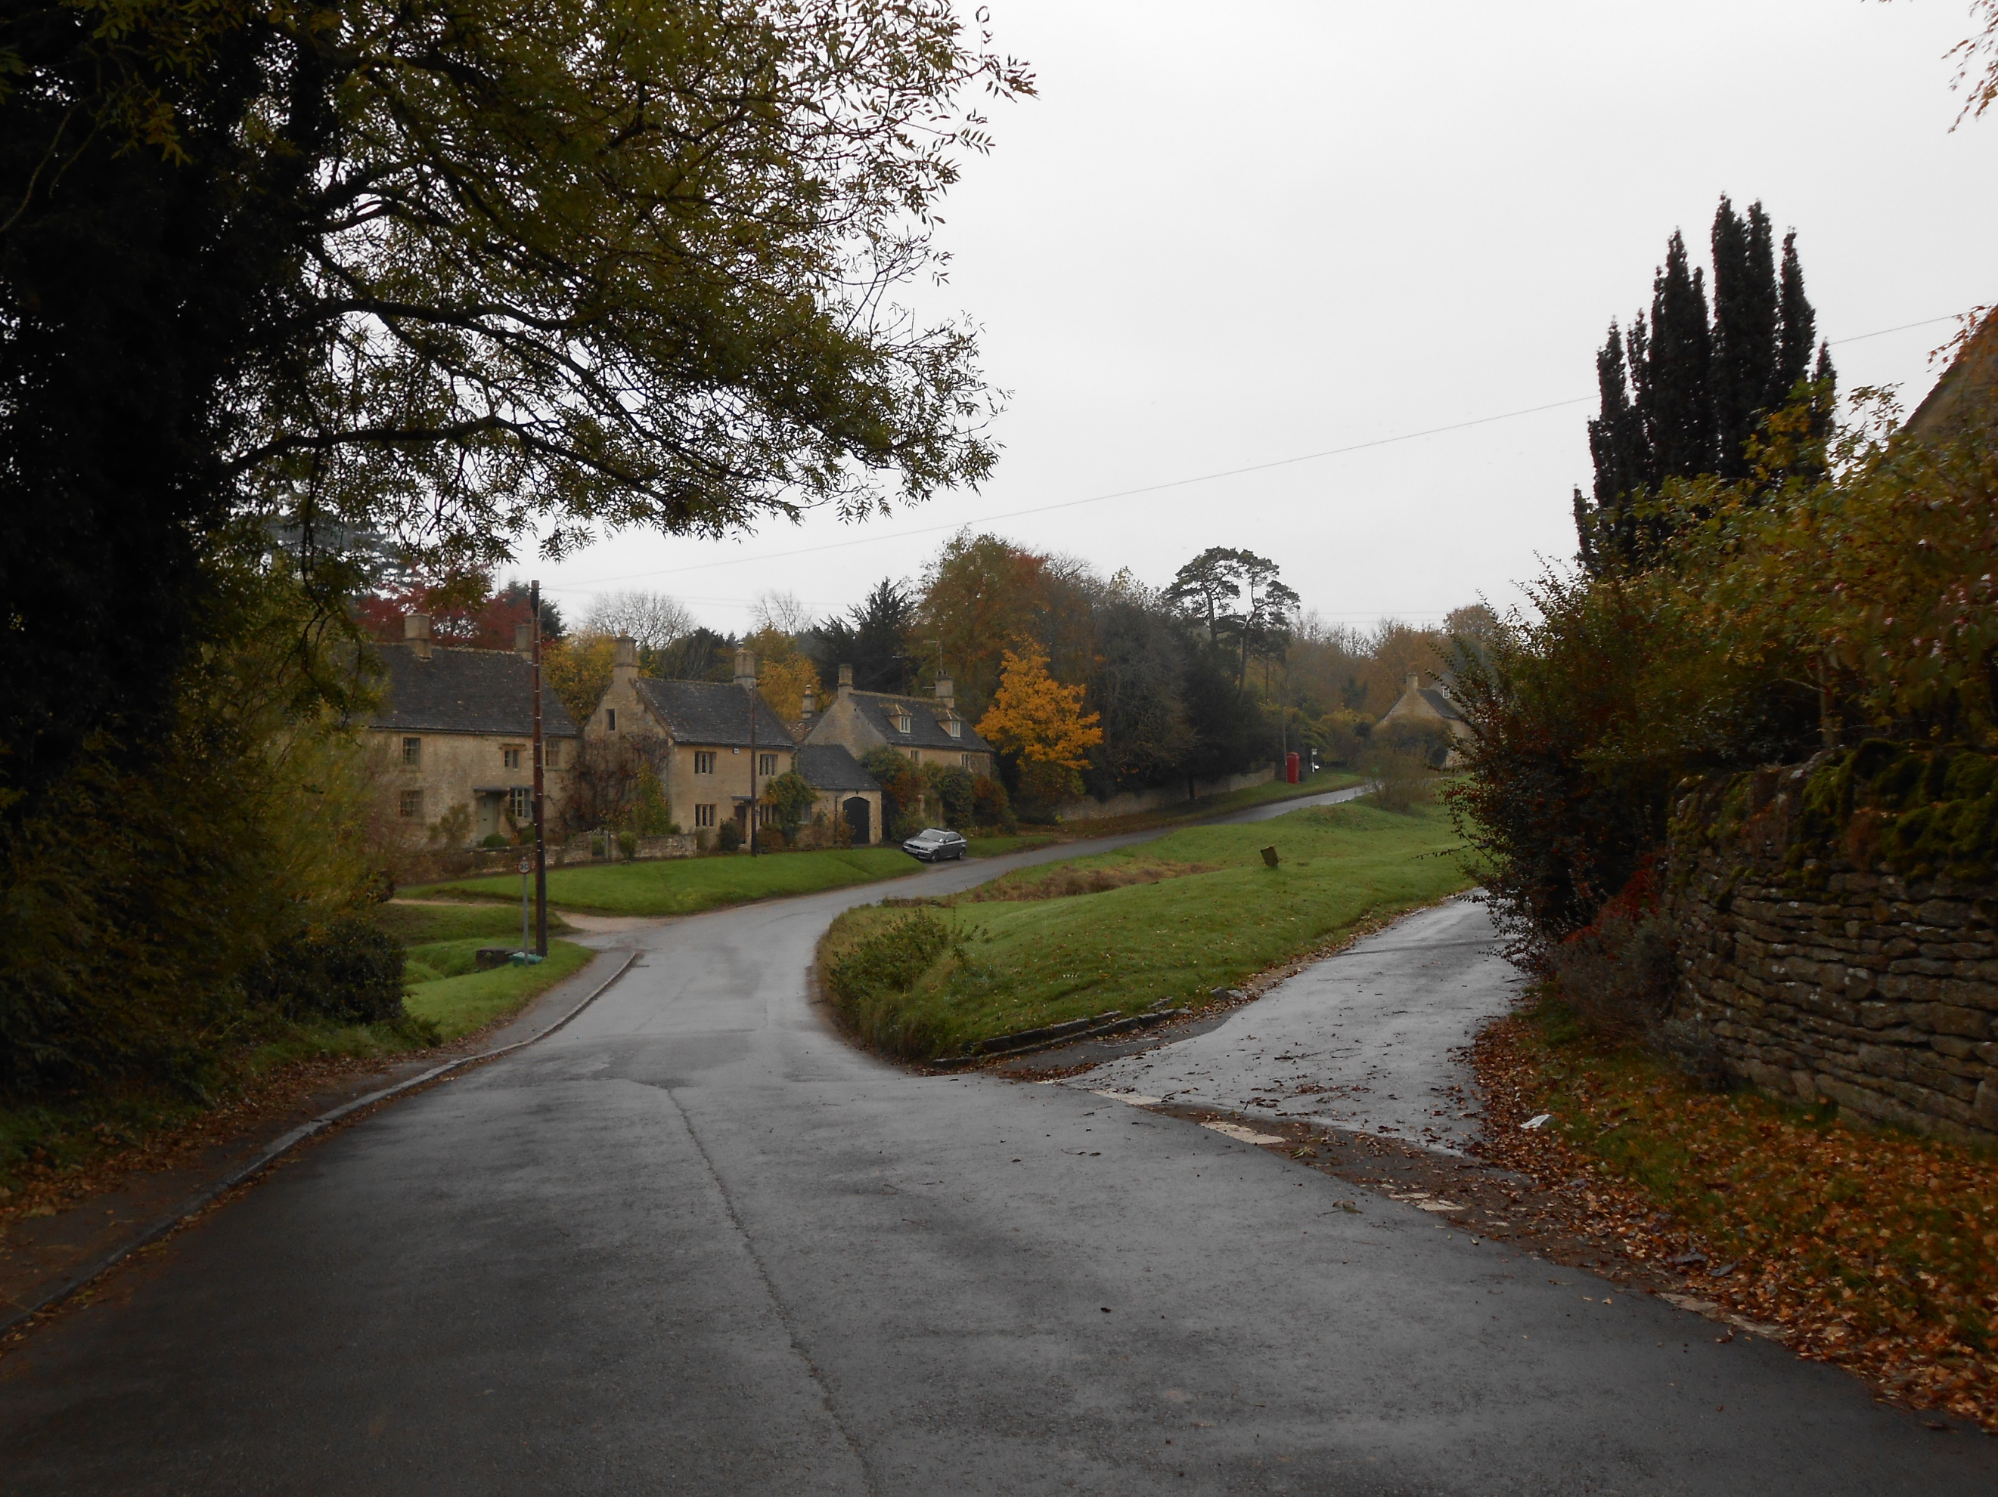

Barrington Parish Council

Application pack for the post of Parish Clerk and Responsible Financial Officer (RFO)

August 2025

Barrington Parish Council
Vacancy for Parish Clerk and Responsible Financial Officer (RFO)
Barrington Parish Council is a small Parish Council that seeks an enthusiastic and competent person to take on the post of Clerk to the Council and Responsible Financial Officer (RFO).
As the Council’s Proper Officer, you will be the primary source of legal and procedural guidance, working closely with the Parish Chairman to ensure our collective decisions remain transparent and lawful.
The post is part-time, working three hours per week from home. The hours of work are variable except for attendance at four Parish Council meetings each year – usually March, May, October and December.
The salary is based on the National Association of Local Councils’ pay scale, SCP 2, LC1 (5-6), currently £13.47 per hour (£2,101 p.a.).
Prior relevant experience in a similar role is an advantage, especially experience advising elected members, but training in all aspects of local government administration can be made available with the agreement of the parish councillors.
Our Clerk must enjoy the opportunity to self-manage tasks, confidently interpret regulations and be IT literate. You must be able to store Council files securely at home and be available to attend regular Council meetings in The Reading Room Little Barrington, Gloucestershire.
Duties will include acting as the Council’s principal advisor, minute-taking, and compiling correspondence, filing and accounts, serving as the RFO to the council, administering the Parish Website, and facilitating councillor development and providing the best service for local residents.
A Job Description and Person Specification are available on the Barrington Parish Council website, or by email from the Parish Clerk.
Applications are by CV with an accompanying letter (no more than two sides A4) to be sent to the Clerk; Mrs Tan Marchant: -

Email: barringtonpc@hotmail.co.uk
Website: www.barringtonpc.com

Closing date: 31 August 2025
Interviews: September/October 2025
Starting date: as soon as possible to allow for a suitable handover

Barrington Parish Council
Parish Clerk and Responsible Financial Officer (RFO)
Person specification

Essential | Desirable
Qualifications and training
Good Level of numeracy and literacy.  Minimum GCSE English & Maths | Certificate of Local Council Administration (CILCA) [Level 3], or willingness to undertake the qualification  Further qualifications related to Government Administration and organisations
Knowledge, skills and experience
Ability to work individually, using own initiative with the ability to problem solve.  Ability to prioritise work, set and meet deadlines.  Demonstration of excellent organisation skills.  Experience of providing administrative support to a Council, or an equivalent role .  A good knowledge of MS Office [Word, Excel] and Outlook for the production of Agendas, Papers, Reports, Minutes, Publicity and Financial reports.  Some experience of bookkeeping and budgeting  Experience of general office procedures including filing.  Ability to recognise legal/political consequences of actions being recommended by Councillors. | Experience as a Clerk or Deputy Clerk  A good working knowledge of Local Government structures and practices.  An Understanding of Planning Legislation.  Experience of either of the following:  - risk management and insurance  - website and social media management
Personal Qualities
Ability to communicate at all levels in the community both orally and in writing, with good presentation skills.

Ability to work co-operatively with Councillors.
Ability to follow instructions and procedures.

Experience of successfully building, managing and maintaining effective relationships with the public and external organisations.

Candidates must demonstrate an understanding of and acceptance and commitment to the principles underlying equal opportunities

Personal Circumstances
Ability to work flexibly and at home and also to attend meetings of the Council.  Possession of a computer/laptop and printer/scanner  An understanding and commitment to the goals of The Council.  Current driving licence, own transport, and ability to travel to Council meetings | Living within the parish of Little and Great Barrington or its environs.
Barrington Parish Council is an Equal Opportunities Employer and welcomes applications from all sectors of the community

Barrington Parish Council
Job Description for Parish Clerk and Responsible Financial Officer (RFO)

Overall Responsibilities
The Clerk to the Council/Parish Clerk will be the Proper Officer of the Council and as such is under a statutory duty to carry out all the functions, and in particular to serve or issue all the notifications required by law of a local authority's Proper Officer. The Clerk will be totally responsible for ensuring that the instructions of the Council in connection with its functions as a Local Authority are carried out. The Clerk is expected to advise the Council on, and assist in the formation of, overall policies to be followed in respect of the Authority's activities and in particular to produce all the information required for making effective decisions and to implement constructively all decisions. The person appointed will be accountable to the Council for the effective management of all its resources and will report to them as and when required. The Clerk will be the Responsible Financial Officer and responsible for all financial records of the Council and the careful administration of its finances.

Specific Responsibilities
- To ensure that statutory and other provisions governing or affecting the running of the Council are observed, and to advise Councillors accordingly.

- To prepare, in consultation with appropriate members, agendas for meetings of the Council and its committees and sub-committees.

- To attend all meetings of the Council and prepare minutes for approval.

- To implement the decisions made by the Council.

- To issue notices and prepare agendas and minutes for the Parish Meetings: to attend the meetings of the Parish Council and to implement the decisions made at the meetings that are agreed by the Council.

- To monitor and balance the Council's accounts and bank accounts, and prepare records for audit purposes and VAT.

- To prepare regular financial reports for the Council, covering budget monitoring, fund balances, receipts and payments, payroll summary, and other relevant matters.

- To receive, check for accuracy and prepare for payment all invoices for goods and services. Where relevant, to issue invoices on behalf of the Council for goods and services and to ensure payment is received.

9. To receive correspondence and documents on behalf of the Council and to deal with the correspondence or documents or bring such items to the attention of the Council. To issue correspondence as a result of instructions of, or the known policy of, the Council.
10. To undertake all necessary activities in connection with the management of salaries, conditions of employment and work of the Clerk.
- To maintain the Council’s Asset Register.

- To ensure that the Council's obligations for Risk Assessment are properly met.

13. To act as the representative of the Council as required.
14. To prepare, in consultation with the Chairman or the nominated Councillor, any Council newsletters and assist with their distribution.
15. To prepare, in consultation with the Chairman, press releases about the activities of, and/or decisions of, the Council.
16. To attend training courses or seminars on the work and role of the Clerk as required by the Council.
17. To continue to acquire the necessary professional knowledge required for the efficient management of the affairs of the Council.
18. To maintain the Parish Council website and Facebook page.

