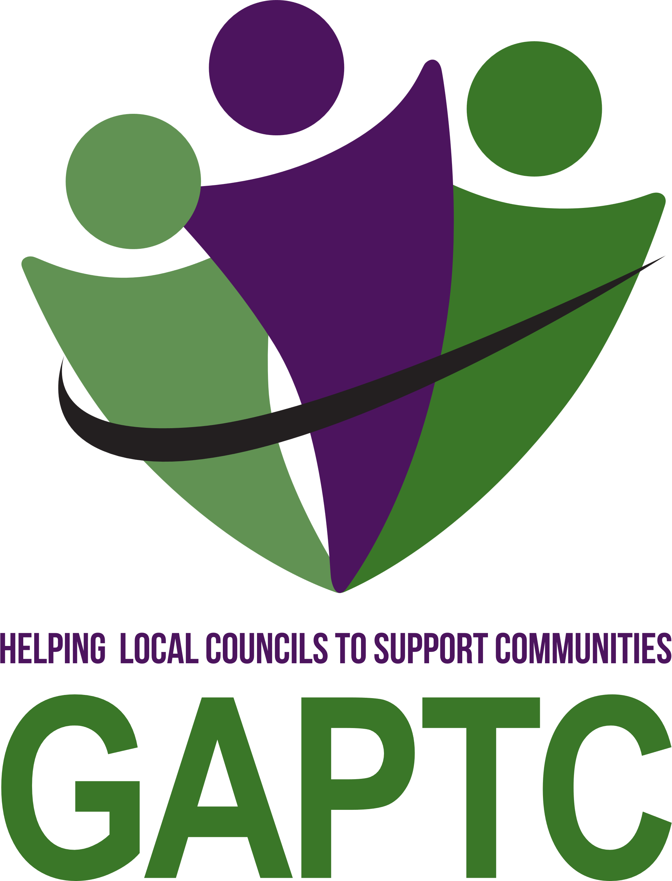

**GLOUCESTERSHIRE ASSOCIATION OF PARISH AND TOWN COUNCILS**

***You are invited to attend***

**The eighty-seventh Annual General Meeting**

on Saturday 20 July 2024

Gambier Parry Hall, Highnam Community Centre, GL2 8DG

Registration from 9.45am

Meeting to commence at 10.30am prompt

**AGENDA**

Welcome to Members by the President, the Rt. Rev. Christopher Hill

***Guest speaker – Jonathan Owen, Chief Executive National Association of Local Councils (NALC) on the role of the national association and its relationship with county associations***

**1. To receive apologies for absence**

**2. To approve the minutes of the eighty-sixth Annual General Meeting held on 24 July 2023 (attached)**

**3.** **To ELECT the following HONORARY OFFICERS**:

(i)(a) President:

Rt. Rev. Christopher Hill is willing to stand again and subject to there being no other nominations received by Thursday, 11th July, it is proposed that Christopher Hill be re-elected.

(i)(b) Vice Presidents:

Councillor Liz Hodges, (Chipping Campden TC) is willing to stand again and subject to there being no other nominations received by Thursday, 11th July, it is proposed that Liz Hodges be re-elected.

(ii) To note that Mr T. E. Parker is an Honorary Life Vice-President.

**4.** **To note the matters arising from the following Resolutions passed at the AGM on 24 July 2021**:

|  |  |
| --- | --- |
| **Proposition Adopted** | **Action Taken/Notes** |
| **Hunts Grove Parish Council**  **Provision for the regulation of fees charged by management companies to freeholders of residential properties; to ensure legal step-in rights, in perpetuity, for self-management of shared facilities by such freeholders, Parish & Town Councils, or other appropriate community groups.** | The proposal to regulate management company fees charged to homeowners, and the granting of legal rights for the self-management of amenities on housing estates, was submitted to NALC's Policy Committee for consideration and adopted as NALC policy.  The motion and its supporting evidence was used by NALC to lobby the Competition and Markets Authority as part of their submission to the CMA's Housebuilding Market Study. Demonstrating that GAPTC motions can influence national policy, the study's final recommendations included: introducing enhanced consumer protection for homeowners regarding management companies, and requiring local councils to adopt amenities on all new housing estates. |

**5. To adopt the 2023-2024 ANNUAL REPORT and FINANCIAL STATEMENT**

(attached)

**6. To debate the following MOTIONS**:

**Councils are reminded that the proposer must be a member of the relevant council and that a seconder from another council is present. Proposers will have four minutes to speak to their council’s motion**

**Quedgeley Town Council**

**That GAPTC request NALC to pursue with HMG. Where a Council clearly demonstrates ongoing and open communication with the public and meets the criteria as below, then the concept of an annual Assembly has now become dated, and the council should be given discretionary powers to forgo an APA. (Part of the discussion of the AGM is to specify the criteria.)**

**For Example.**

**‘Full time’ i.e., 5 days a week, office.**

**Regular update of Media and/or web site.**

**Regular community events. Regular public surgeries.**

**Proof of regular meaningful communication and contact between council and residents throughout the year.**

**Gold Standard Accreditation**

**Chipping Campden Town Council**

**Motion 1**

**In many of our towns and villages, there has been development by ‘creep’ e.g. permission is granted for a small group of 3-5 dwellings. Followed within a year an adjacent 3-5 dwellings and then a further 3-5 dwellings. All too soon what had been a small development which could have enhanced the area now becomes intense (and to many) an overdeveloped area. Therefore, Chipping Campden Town Council requests that GAPTC press HMG through NALC to amend the planning regulations to ensure that where a small development of under (5) dwellings is made, there can be no further development adjacent to that site for at least 10 years. This is proposed to avoid creeping and often insensitive over-development in our rural areas.**

**Motion 2**

**Where a parish/town council has noted that verges have been erroneously or deliberately planted by the householder to enhance the size of their plot or to increase road splay, then the parish or town Council will have the right to demand that the Highways authority take action to remedy. Should the Highways authority fail to act or resolve the situation within 6 months then the Parish/Town Council will be able to negotiate with the occupier of the land to remove the obstruction and where necessary the Highways authority should remain liable for any charges incurred.**

**Wotton-under-Edge Town Council**

**To enable Parish and Town Councils to hold the Annual Parish Meeting at a convenient time more suitable for the electorate rather than being restricted to after 6pm when many people are unavailable.**

**Bourton on the Water Town Council**

**Motion 1:**

**At GAPTC’s AGM in 2023 it was resolved to ask NALC for a policy against estate management companies and a preference towards adoption by local councils/authorities. NALC agreed and this became a national policy of NALC. During 2023/24 the CMA (Competition and Markets Authority) undertook an investigation and concluded the same, recommending that the government act on this. The proposed resolution is as follows:**

**At this 2024 AGM of GAPTC we RESOLVE that NALC should now enhance its policy to encompass the CMA’s conclusion and to lobby all political parties for this as part of preparations for this year’s general election.**

**Motion 2:**

**We ask for Part 3 (Chapter 2, sections 10 and 11) of the Water Act (also Section 2 of the Water Industry Act 1991 applies) to be introduced in England to ensure all water and flood infrastructure (eg SUDS) is in public ownership and control (as is already the case in Wales).**

**7. To discuss the level of subscription for 2025/26, as required by Para 3b of the Constitution, for the Executive Committee to take into consideration when it sets the fee level in the autumn.**

**8. To receive and approve GAPTC constitutional amendments.**

Insert a new paragraph 2(b): "Except with the express consent of the Association's Executive Committee, human resources and legal services provided by the Association shall only be available to Member Councils whose subscription payments are up to date and have been members of the Association for a minimum period of six calendar months."

Re-number the former 2(b) as paragraph 2(c) and delete the words: "following consultation at the AGM,".

Amend paragraph 7(a)(iv) by adding the words "Save for the representative clerk" at the beginning of the paragraph.

Delete the existing paragraph 7(a)(viii) and insert the following: "All members of the Executive Committee retire together every four years after the local government election cycle (commencing with the election cycle which began in May 2023) but shall be eligible for re-election."

Amend paragraph 7(a)(ix) by changing the term "May elections" to "May local government elections".

Throughout the constitution, change all mentions of "Chief Officer" to "Chief Executive Officer".

**9. To receive any other items of urgent business as notified to the President prior to the commencement of the meeting and at the discretion of the Chairman.**

**10. Sponsors presentations**

1. *Cloudy IT*

CloudyIT leads the charge in modernising Town and Parish Council operations in England and Wales, driving digital progress in local governance. As a top managed service provider, they elevate efficiency, security, and community engagement with tailored solutions. Their GovSuite platform integrates CRM, marketing, and finance tools, streamlining council workflows for effective constituent relations, communication, and financial oversight. Launching soon, GovAssist is an AI companion automating tasks, offering data-driven insights, and enhancing decision-making. Additionally, CloudyIT provides core IT services like .gov.uk email setups and Microsoft 365 integration, vital for seamless operations and communications. Their expertise extends to supporting organisations like the Society of Local Council Clerks (SLCC) and the National Association of Local Councils (NALC).

CloudyIT offers councils a digital roadmap for advancement in public service. Explore your council's digital potential today.

1. *Utility Aid*

Utility Aid, the UK's premier energy broker for non-profits, partners with NALC to offer expert assistance. Their dedicated team manages your portfolio, handling procurement, Bureau services, account management, audits, carbon reporting, and net zero planning. Charity clients have saved over £6.7 million through their invoice validation services. We help you find budget-friendly suppliers tailored to your needs, ensuring more resources for frontline services. Committed to ethical energy provision, we operate transparently. To access support, provide annual consumption data and a recent bill. We'll compare costs with credit-checked suppliers, handle administrative tasks, and offer full account management and invoice validation. Simply sign and relax while we optimize your energy provision.

1. *Blanchere Illumination*

GLOBAL LEADERS IN ECO RESPONSIBLE FESTIVE LIGHTING

Blachere Illumination UK creates amazing commercial Christmas displays for town and parish councils, shopping centres, markets, theme parks, and more. Our eye-catching indoor and outdoor lighting schemes bring the retail areas to life for the festive season and create an uplift in spirits and spending alike at Christmas. We also provide for other seasons -Summer and Halloween etc. No budget or job size too small – we can also create any bespoke pieces your council may require.

Blachere Illumination are global leaders in the provision of Eco Responsible lighting with their most recent range made from recycled plastic bottles.

We have been making Festive decorations for over 50 years.

Have your council signed up to a climate emergency plan? Then we can help.

1. *Streetscape*

Introducing Streetscape's new product brochure! Based in Selby, North Yorkshire, we've been designing, manufacturing, and installing outdoor play, sport, and fitness facilities for over 35 years. Our wide range includes timber and steel playground equipment, outdoor fitness gear, multi-use games areas, and safety surfacing. Serving local authorities, schools, architects, and communities, we tailor solutions to your needs, meeting European Safety Standards. Our brochure showcases our hands-on approach, featuring case studies and references. Explore our full product range, including new additions, and visit our websites for updates. Plus, discover our YouTube channel with QR codes for quick access to demos. Join us in creating vibrant outdoor spaces!

***A buffet lunch will be served at the end of the meeting***

***Opportunity to network***